Epsom & Ewell F.C.
15
v
Chertsey Town F.C.
Saturday, 17th December 2016 – 3.00 p.m.
Good afternoon! We welcome the players, supporters and officials of Chertsey Town, today’s officials and of course, our own regular faces for our final match before Christmas!

After a number of years where we found ourselves often playing the supporting role against Chertsey, they have had a couple of tough years since returning to the Combined Counties League and were extremely fortunate to avoid relegation in 2014/15 when only finishing above Frimley Green. Last season they escaped by six points and this term they face another tough battle to stay up, which right now it looks as though they are winning.

Last year Chertsey won 1-0 here in a low quality game, but with a high quality winning free kick goal by Andy Crossley. However, we won easily in the return match at Alwyns Lane by five goals to three. In fact, we will return there in February looking for our fourth straight win over there. Until this run started we had never even won twice in a row at Alwyns Lane!

Our last match was at home to Hanworth Villa just four days ago and we were fortunate to get a point in the end, requiring a 93rd minute equaliser from Jordan Gallagher to salvage a 2-2 draw. We were very slow out of the blocks and didn’t register a shot on target in the first half, but played a lot better in the second, although conceding a second goal in the 85th minute gave us a mountain to climb. A draw against a team in third place is acceptable but we need to start closing the gap on them very soon if we want a top four finish or higher. As the table stands, we can still go fourth if we win our games in hand but we’ll need to play better than we did on Tuesday to achieve this.

Our next match is on Tuesday 27th December when we host Raynes Park Vale with the kick off at 11.30 am. Then we visit Sutton Common Rovers at Sutton United on Monday 2nd January in a match that starts at 12.00 pm. Finally, please also note that our Surrey Senior Cup tie against Guildford City will take place here on Tuesday 10th January

We had two winners on the Super Six this midweek with Rita Christian and Matt Parker winning £280 each. The jackpot resets to £50 today, but please keep supporting your club by buying tickets.

Enjoy the game!

Rich

You can follow us on Facebook: www.facebook.com/epsomandewellfc Twitter: @EEFCOfficial and
Instagram at: www.instagram.com/epsomandewellfc We also have a Youtube channel now!

Cover photos by Gemma Jarman

- Dan Dean receives the Dave Wilson Trophy from our Wembley 1975 goalkeeper Chris Page

- Bentley Graham opens the scoring for us in our last meeting, a 5-3 win in March

Cherry Red Records Combined Counties League
Premier Division Table 2016/17
incl Tuesday 13th December | P | W | D | L | F | A | Pts | GD | H | A
Hartley Wintney | 24 | 20 | 2 | 2 | 79 | 23 | 62 | +56 | 18/3 | 1-3
Westfield | 22 | 15 | 5 | 2 | 51 | 21 | 50 | +30 | 18/2 | 1-2
Hanworth Villa | 25 | 14 | 4 | 7 | 40 | 30 | 46 | +10 | 2-2 | 14/1
Walton & Hersham | 21 | 12 | 7 | 2 | 35 | 17 | 43 | +18 | 4/3 | 1-1
Knaphill | 22 | 12 | 2 | 8 | 47 | 40 | 38 | +7 | 4-0 | 8/4
Guildford City | 26 | 11 | 5 | 10 | 55 | 52 | 38 | +3 | 17/1 | 2-0
Epsom & Ewell | 21 | 10 | 5 | 6 | 51 | 32 | 35 | +19 | X | X
Horley Town | 21 | 10 | 5 | 6 | 43 | 30 | 35 | +13 | 3-0 | 17/4
Windsor | 25 | 10 | 5 | 10 | 45 | 43 | 35 | +2 | 2-0 | 1-2
Colliers Wood United | 23 | 9 | 6 | 8 | 40 | 38 | 33 | +2 | 14/4 | 0-5
Bedfont Sports | 20 | 9 | 5 | 6 | 38 | 38 | 32 | 0 | 5-1 | 7/2
Camberley Town | 22 | 9 | 4 | 9 | 40 | 29 | 31 | +11 | 0-0 | 1/4
Spelthorne Sports | 22 | 8 | 5 | 9 | 37 | 35 | 29 | +2 | 7/1 | 25/2
North Greenford United | 21 | 8 | 4 | 9 | 45 | 43 | 28 | +2 | 22/4 | 1-2
Abbey Rangers | 23 | 8 | 4 | 11 | 34 | 43 | 28 | -9 | 7-1 | 20/2
CB Hounslow United | 21 | 8 | 2 | 11 | 35 | 45 | 26 | -10 | 1-5 | 12/11
Farnham Town | 21 | 7 | 2 | 12 | 33 | 45 | 23 | -12 | 25/3 | 2-1
Sutton Common Rovers | 20 | 6 | 3 | 11 | 27 | 38 | 21 | -11 | 2-1 | 2/1
Chertsey Town | 23 | 5 | 6 | 12 | 27 | 56 | 21 | -29 | 17/12 | 11/2
AFC Hayes | 22 | 5 | 5 | 12 | 33 | 47 | 20 | -14 | 2-2 | 28/1
Raynes Park Vale | 23 | 4 | 5 | 14 | 30 | 50 | 17 | -20 | 27/12 | 1-1
Badshot Lea | 23 | 5 | 2 | 16 | 30 | 63 | 17 | -33 | 4/2 | 4-1
Bedfont & Feltham | 23 | 3 | 5 | 15 | 28 | 65 | 14 | -37 | 21/1 | 9-2

Lucky Day? – 17th December
Played 14 - Won 6 Drawn 4 Lost 4 - For 29 Against 32 - PPG 1.57 - Above Average
Our Club record against Chertsey Town
Played 47 - Won 17 Drawn 5 Lost 25 - For 70 Against 86 - PPG 1.19 - Below Average
Our Largest wins and losses against our opponent
Won 3-0 - on three separate occasions
8th March 1994 - L 0-7 - Isthmian League Associate Members Trophy QF (H)
Their Last Visit
17th October 2015 - Lost 0-1 - Combined Counties League

First Eleven Appearances 2016/17 - (max 29)
Name | Debut | 2016/17 |  |  |  | Career Totals
 |  | App | Sub | Total | Goals | App | Sub | Total | Goals
CLARK-GLEAVE Charlie | 23/08/2016 | 2 | 2 | 4 | 0 | 2 | 2 | 4 | 0
COOPER-SMITH Daryl | 03/01/2015 | 22 | 1 | 23 | 25 | 52 | 9 | 61 | 45
DEAN Dan | 02/08/2014 | 20 | 2 | 22 | 0 | 88 | 6 | 94 | 2
DEWAR Ali | 29/10/2011 | 0 | 1 | 1 | 0 | 55 | 36 | 91 | 10
EACOTT Michael | 02/08/2014 | 22 | 0 | 22 | 0 | 107 | 1 | 108 | 0
FARRELL Matt | 02/08/2014 | 27 | 0 | 27 | 13 | 113 | 4 | 117 | 31
FERDINANDO Matt | 20/09/2014 | 15 | 4 | 19 | 2 | 68 | 10 | 78 | 16
GALLAGHER Jordan | 07/08/2016 | 15 | 12 | 27 | 7 | 15 | 12 | 27 | 7
GRIFFIN Reisse | 08/08/2015 | 20 | 5 | 25 | 2 | 48 | 11 | 59 | 4
HASTINGS Craig | 08/08/2015 | 19 | 5 | 24 | 1 | 56 | 9 | 65 | 1
HEAGNEY Adam | 16/08/2016 | 18 | 3 | 21 | 0 | 18 | 3 | 21 | 0
HENDRY Rob | 08/08/2015 | 19 | 7 | 26 | 3 | 49 | 18 | 67 | 15
MCKAY Alex | 20/12/2008 | 16 | 3 | 19 | 3 | 124 | 33 | 157 | 11
NEALE Tom* | 13/10/2015 | 6 | 5 | 11 | 7 | 22 | 24 | 46 | 17
NORTH Rhys* | 16/08/2015 | 2 | 2 | 4 | 0 | 19 | 9 | 28 | 1
NWACHUKWU Jason | 01/10/2016 | 4 | 7 | 11 | 0 | 4 | 7 | 11 | 0
PANAYIOTOU Savvas | 03/01/2015 | 22 | 3 | 25 | 4 | 54 | 11 | 65 | 11
PRICE Matt* | 23/08/2016 | 2 | 0 | 2 | 1 | 2 | 0 | 2 | 1
ROBINSON Sam* | 22/10/2011 | 7 | 1 | 8 | 1 | 61 | 6 | 67 | 14
ROSE Daniel | 25/10/2016 | 2 | 4 | 6 | 0 | 2 | 4 | 6 | 0
SALEH Mennar* | 24/09/2016 | 0 | 2 | 2 | 0 | 0 | 2 | 2 | 0
SMITH Matt | 08/08/2009 | 0 | 2 | 2 | 1 | 91 | 45 | 136 | 11
TANTON Matt | 02/08/2014 | 25 | 1 | 26 | 1 | 82 | 5 | 87 | 3
TAYLOR James | 26/08/2013 | 23 | 3 | 26 | 2 | 109 | 15 | 124 | 8
THOMPSON Elliott | 09/02/2016 | 3 | 0 | 3 | 1 | 7 | 9 | 16 | 1
TURPIE Alistair | 31/03/2016 | 7 | 1 | 8 | 0 | 9 | 1 | 10 | 0
WATRET Jack* | 02/08/2016 | 1 | 0 | 1 | 0 | 1 | 0 | 1 | 0
* player has left the club

Latest Results and Fixtures
Combined Counties League – Monday 12th December
Sutton Common Rovers | 1-3 | Abbey Rangers
Surrey Senior Cup Second Round – Tuesday 13th December
Badshot Lea | 1-0 | Farnham Town
Combined Counties League – Tuesday 13th December
Bedfont & Feltham | 2-2 | Chertsey Town
Camberley Town | 2-1 | CB Hounslow United
Epsom & Ewell | 2-2 | Hanworth Villa
Walton & Hersham | 0-0 | Bedfont Sports
Surrey Senior Cup Second Round – Wednesday 14th December
Guildford City | 3-3 | Horley Town
Guildford City win 3-2 on penalties
Combined Counties League – Saturday 17th December
AFC Hayes | V | Guildford City
Abbey Rangers | V | Walton & Hersham
Camberley Town | V | Bedfont & Feltham
CB Hounslow United | V | Bedfont Sports
Epsom & Ewell | V | Chertsey Town
Farnham Town | V | Colliers Wood United
Horley Town | V | Windsor
Knaphill | V | Hartley Wintney
North Greenford United | V | Westfield
Raynes Park Vale | V | Sutton Common Rovers
Spelthorne Sports | V | Hanworth Villa
Combined Counties League Cup Third Round – Monday 19th December
Sutton Common Rovers | V | Walton & Hersham
Combined Counties League – Tuesday 27th December (11.30am k.o.)
Abbey Rangers | V | Spelthorne Sports
Bedfont & Feltham | V | CB Hounslow United
Bedfont Sports | V | North Greenford United
Camberley Town | V | Farnham Town
Chertsey Town | V | Horley Town
Epsom & Ewell | V | Raynes Park Vale
Hanworth Villa | V | AFC Hayes
Hartley Wintney | V | Badshot Lea
Walton & Hersham | V | Westfield
Windsor | V | Knaphill
Combined Counties League – Wednesday 28th December
Colliers Wood United | V | Sutton Common Rovers

From behind the goal
Epsom & Ewell 2-2 Hanworth Villa
Combined Counties League - Premier Division - Tuesday 13th December 2016

Late Gallagher strike salvages a point

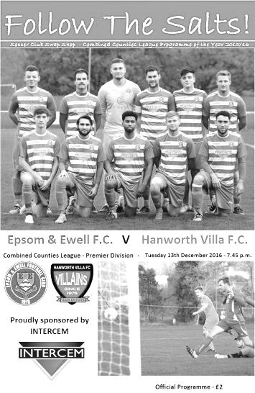
A 93rd minute left footed strike by Jordan Gallagher enabled us to rescue a point from a match that had looked like slipping away from us.

In terms of personnel Michael Eacott was nursing a hip injury so Ali Turpie came in between the posts, while after Rob Hendry's fine performance against Hartley Wintney, Agi Panayiotou dropped to the bench to accommodate the return after suspension of Daryl Cooper-Smith.

Following any injustice at Hartley on Saturday I expected us to play well. I thought we would be fired up and the first ten minutes seemed to indicate just that. We pressed, harried, and controlled the early stages, while the visitors, shorn of many regulars through injury, looked as if they were just finding their feet. However, the dynamic of the match changed entirely in the 19th minute when a hospital ball was intercepted and the pass out to the right found former Salt Tom Neale who cut back onto his left foot and drilled the ball low beyond Turpie from the edge of the penalty area. It's not the first time we have conceded goals to former players, but this one seemed to hit us badly and any anger and injustice we may have been using as a positive appeared to turn into anger and frustration and anger with each other.

We created very little for a while with the visitors compressing midfield, leading to a number of balls over the top running straight through to Balvinder Khaira, the former AFC Hayes keeper now with the Villains. Fortunately very little was created by the visitors also and we rarely looked like conceding a second. Cooper-Smith controlled a ball well before beating his man and sending a shot from the edge of the area at a good height, but a couple of yards wide of the far post, while towards the end of the half Adam Heagney, getting quite a bit of space, sent over a ball that Matt Farrell reached but was stretching and was unable to direct his header on target. As we went off it was worth noting that we had not registered a shot on target.

Clearly things needed sorting out at half time and I'm aware that discussion was heated. Glyn made a change at half time with Cooper-Smith replaced by Jason Nwachukwu, with Hendry playing up top as he did on Saturday. This paid an almost instant dividend as a Gallagher free kick in the 47th minute found our newly introduced substitute in space, although his header went across goal from eight yards. Fortunately,

James Taylor was there and although his first touch let him down a little, he was able to recover to get a shot in which hit the bar but dropped down just over the line before being cleared. To our relief, the Assistant also saw this and we were level.

From this point we were back in the game. The first half now forgotten, we began to exert a bit of pressure although again the quality of the final ball was letting us down as it had in the first half. There were occasional chances with Hendry getting a shot on target from the edge of the area but it was lacking in real power and was gathered easily. We had to be alert on occasions and Turpie had to head the ball clear a couple of times as were exposed a little by the pace of the Hanworth counter attacks.

Another dangerous cross from Heagney was flicked away just in front of the waiting Nwachukwu for a corner and we were awarded a few more corners in this match as the pressure began to build. In the 74th minute a Gallagher piledriver looked like it was going in from where I was, but the ball was blocked by a defender and on the counter attack, a right wing Hanworth cross dropped onto our bar and the danger was cleared.

We were still doin the majority of the pressing, though time was running out and a low ball in from Matt Tanton on the left was dummied brilliantly for Nwachukwu but Hendry dragged his low shot a couple of feet beyond the far post before Nwachukwu then saw his powerful shot deflected behind for a corner from the next attack. Then Craig Hastings got his head to the ball but was unable to keep his header on target from another Gallagher corner.

It looked like we would have to settle for the 1-1 draw but the visitors had other ideas and broke down the right with a low cross tapped in from close range by Neale again in the 85th minute. This was a disaster and in all honesty I hadn't seen it coming as it had looked like there would only be one team winning this match, but now we were up against it. Fortunately a clumsy challenge on Nwachukwu that earned their Captain Luke Muldowney a yellow card, gave us a free kick in the opposition half with seconds remaining. The deep delivery was headed back by Hastings and Gallagher waiting on the edge of the area lashed the ball through a crowd of players into the bottom corner with what proved to be the last kick of the game, barring the subsequent kick off.

This was a strange game to analyse. Clearly our boys deserve credit for fighting back twice but we didn't play well enough for long enough to say we deserved any more. Having said that, for all our second half pressure, it still feels like two points dropped. The visitors will certainly feel that way too, but in the cold light of day will probably admit that they'd have taken a point before the game due to their player shortages. Ultimately a point each was almost certainly the correct result in a match that was extremely well officiated by all three men in black.

Epsom and Ewell: Ali Turpie, Adam Heagney, Matt Tanton, James Taylor,
Craig Hastings, Dan Dean (c), Jordan Gallagher, Matt Farrell, Rob Hendry,
Daryl Cooper-Smith, Matt Ferdinando

Subs: Jason Nwachukwu for Cooper-Smith (46), Reisse Griffin for Ferdinando (68)

Chertsey Town – History
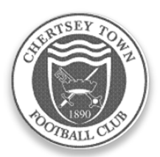
Organised football was evident in Chertsey well over a century ago but county affiliation did not take place immediately. The official founding of the club took place in 1890 when matches were played in the West Surrey League. The first success came in 1897 when the Surrey Junior Cup was secured. A one year gap took place before football resumed in the same competition which eventually became the East and West Surrey League.

A further halt in football took place during the Great War but soon after, in 1919, the club joined the Surrey Intermediate League where it stayed uneventfully, until 1939 and a further break. An invitation to become founder members of the Surrey Senior League was not taken up in 1923 but membership was later assumed, on attaining senior status in 1946.

The club has played at various locations within the parish (Willow Walk, Free Prae Road, Stained Lane and Chilsey Green Road) before settling down at the present home in 1929. The suffix ‘Town’ was added to its title some 21 years later. The ground was donated by Sir Edward Stern as a football ground to the ‘premiere club in the parish’. Next door, a similar trust provides facilities for Chertsey Cricket Club. The main stand was constructed in the mid-fifties; the original clubhouse added in 1960 and the first covered enclosure was built some three years later. Cover behind one goal was added in 1994.

Although Chertsey gained membership of the Surrey Senior League immediately after the Second World War, it was not until the 1959/60 season that success came with the League Championship. This was repeated twice in the next three years, a halcyon period when the League Cup was also won on three occasions. Due to the static nature of Amateur football in those days, the club could not progress to the preferred Corinthian League so, in 1963, it was controversially decided to turn professional and enter the Metropolitan League. Although an entertaining three years were then enjoyed, the cost was too much to bear and a return to lower levels of the Greater London League for one season occurred before a further shift to the Spartan League was made in 1967.

Indifferent results then dogged the club for almost two decades. This situation was briefly relieved in 1974/75 when the club were League and League Cup runners up to an up and coming Farnborough Town. Meanwhile, the fabric of the club was being built up behind the scenes and despite the lack of

prominence on the park, movement was made via the London Spartan (1975/76) and Athenian leagues through to the Isthmian family with a place in Division Two South in 1984. Instant relegation to the Combined Counties League was suffered but, a rejuvenated side won promotion back to the Isthmian ranks within the year winning the League Cup on the way.

The club was rewarded with good league positions but with further promotion denied at first. The worst season after returning to the Isthmians came when the two Division Twos were split in 1991 and a place in the new Division Three had to suffice. The position was quickly rectified with a runners up slot in 1992.

The club also reached the quarter finals of the F.A. Vase, emulating a similar performance in 1987/88. One year later 102 points and a runners up promotion place to Division One was nailed. The League Cup was also secured together with the Carlsberg Trophy in the same campaign along with the League Charity Shield.

Only one campaign was required in Division One before further promotion to the Premier Division. The first season at that level was one of consolidation but the second was more difficult. A late rally was experienced, but was insufficient to avoid the drop to Division One. Two subsequent Division One campaigns were comfortable but the third proved too difficult after a very poor first half of the season.

Relatively respectable positions were attained for the next two seasons and then a return to Division One, taking a place in the revised south section in the Isthmian re-organisation. The side was not able to compete at this level and relegation to Division Two was suffered in 2003. With the dissolution of the division, the club was allocated to Combined Counties in 2006. Promotionally hopeful situations were created regularly over the five terms in that competition. Finishing as runners up in 2011 was good enough on that occasion to secure promotion to Division One Central of the Southern League. Unspectacular, but safe, performances were achieved for two seasons but the relegation was suffered at the end of last season, and with it a return to the Combined Counties League.

The club which also has a comprehensive and integrated junior section of boys from all ages is sponsored by Traylen Enterprises; a nearby company that takes a great deal of interest in local community projects. The club now also supports a ladies team who play in the Greater London League.

Chertsey Town’s nickname, the ‘Curfews’ is derived from a locally famous bell that hangs in the nearby St. Peters Church. The bell has rung out the evening curfew, now ceremoniously of course, for over five hundred years.

Combined Counties League Premier Division Opponents
All-time Records
incl Tuesday 13th  December | P | W | D | L | F | A | PPG | GD | Best  Win | Worst  Loss
Bedfont & Feltham | 1 | 1 | 0 | 0 | 9 | 2 | 3.00 | +7 | 9-2 | X
Spelthorne Sports* | 5 | 4 | 1 | 0 | 15 | 6 | 2.60 | +9 | 6-2 | X
Sutton Common Rovers | 11 | 9 | 1 | 1 | 29 | 13 | 2.55 | +16 | 4-0 | 1-4
Horley Town | 29 | 20 | 5 | 4 | 65 | 30 | 2.24 | +35 | 6-0 | 1-3
Colliers Wood United | 22 | 14 | 2 | 6 | 45 | 33 | 2.00 | +12 | 4-0 | 0-5
Bedfont Sports | 10 | 6 | 2 | 2 | 18 | 11 | 2.00 | +7 | 5-1 | 0-4
Abbey Rangers | 3 | 2 | 0 | 1 | 10 | 4 | 2.00 | +6 | 7-1 | 2-3
Westfield | 19 | 11 | 3 | 5 | 40 | 31 | 1.89 | +9 | 6-1 | 0-4
Farnham Town | 14 | 8 | 2 | 4 | 25 | 23 | 1.86 | +2 | 3-1 | 1-4
Knaphill | 7 | 4 | 1 | 2 | 15 | 8 | 1.86 | +7 | 4-0 | 1-2
Guildford City | 17 | 10 | 1 | 6 | 34 | 22 | 1.82 | +12 | 5-1 | 1-5
Hanworth Villa | 16 | 8 | 4 | 4 | 38 | 26 | 1.75 | +12 | 5-0 | 1-4
Raynes Park Vale | 27 | 13 | 6 | 8 | 58 | 37 | 1.67 | +21 | 6-1 | 0-2
Badshot Lea | 18 | 8 | 3 | 7 | 35 | 34 | 1.67 | +1 | 4-1 | 0-4
Walton & Hersham | 50 | 24 | 10 | 16 | 101 | 97 | 1.64 | +4 | 6-0 | 0-8
Camberley Town* | 89 | 38 | 22 | 28 | 158 | 123 | 1.52 | +35 | 9-1 | 0-4
Hartley Wintney | 11 | 4 | 3 | 4 | 26 | 20 | 1.36 | +6 | 5-0 | 2-4
Windsor | 49 | 19 | 12 | 18 | 90 | 90 | 1.41 | 0 | 4-0 | 0-6
Chertsey Town | 47 | 17 | 5 | 25 | 70 | 86 | 1.19 | -16 | 3-0 | 0-7
AFC Hayes | 9 | 2 | 3 | 4 | 18 | 17 | 1.00 | +1 | 7-0 | 0-3
North Greenford United | 11 | 3 | 2 | 6 | 15 | 20 | 1.00 | -5 | 3-0 | 1-4
CB Hounslow United | 2 | 0 | 0 | 2 | 2 | 7 | 0.00 | -5 | X | 1-5
* includes one abandoned match v Camberley and one loss on penalties v Spelthorne

Club Records - 17th December
Date | Day | Competition |  | Opponents |  | Scorers
17/12/27 | Sat | East Surrey Hospital Cup 1 | H | Aquarius | 1-0 | F.Behn
17/12/32 | Sat | London League | A | Beckenham | 0-0
17/12/38 | Sat | London League | H | Bostall Heath | 5-5 | F.Stenning (3), J.Jones, B.Evans
17/12/49 | Sat | Corinthian League | A | Hounslow Town | 0-5
17/12/55 | Sat | Corinthian League | A | Edgware Town | 1-1 | D.Hermitage
17/12/60 | Sat | Corinthian League | A | Worthing | 2-1 | B.Hawkins, B.Robinson
17/12/66 | Sat | Athenian League 2 | A | Wingate | 7-5 | A.Cox (2), T.Williams (2), T.Williamson, C.Spriggs, o.g.
17/12/77 | Sat | F.A. Vase 3 | H | Ringmer | 4-0 | S.Delaney (2), T.Coombe, R.Parkin
17/12/83 | Sat | Isthmian League 1 | A | Kingstonian | 0-1
17/12/85 | Tue | Isthmian League Cup 3 | H | Dulwich Hamlet | 3-2+ | R.Kidd (2, 1 pen), P.Kemp
17/12/88 | Sat | F.A. Vase 3 | A | Wick | 1-1+ | B.Perkins
17/12/94 | Sat | Isthmian League 3 | H | Flackwell Heath | 3-1 | S.Miller (2), G.Meakin
17/12/05 | Sat | Isthmian League 2 | A | Ware | 0-7
17/12/11 | Sat | Combined Counties  Premier Division | H | Cove | 2-3 | Matt Smith (pen), J.Cottee
Historical Decades
Date | Day | Competition |  | Opponents |  | Scorers
90 years ago – Epsom Town F.C.
18/12/26 | Sat | Surrey Senior Cup 4q replay | A | Carshalton Athletic | 2-2+ | H.Westlake (pen), A.Mackesy
80 years ago – Epsom F.C.
19/12/36 | Sat | Friendly | H | Fulham Reserves | 8-2 | B.Randall (3), H.Pullen (2), J.Jones, G.Collins, C.Staples
70 years ago – Epsom F.C.
14/12/46 | Sat | London League | A | Eton Manor | 0-5
60 years ago – Epsom F.C.
15/12/56 | Sat | Surrey Senior Cup 1 | H | Kingstonian | 5-1 | B.Jenkins, J.Sorensen, D.Hermitage, J.Bangs, T.Day
50 years ago – Epsom & Ewell F.C.
17/12/66 | Sat | Athenian League 2 | A | Wingate | 7-5 | A.Cox (2), T.Williams (2), T.Williamson, C.Spriggs, o.g.
40 years ago – Epsom & Ewell F.C.
11/12/76 | Sat | Surrey Senior Cup 4q | A | Redhill | 5-0 | T.Tuite (2), K.Eshelby, A.Webb, A.Reid
30 years ago – Epsom & Ewell F.C.
13/12/86 | Sat | Isthmian League 1 | A | Tilbury | 0-1
20 years ago – Epsom & Ewell F.C.
21/12/96 | Sat | Isthmian League 3 | H | Aveley | 3-5 | P.Meredith, A.Boxall, M.Jones
10 years ago – Epsom & Ewell F.C.
12/12/06 | Tue | Surrey Senior Cup 2 | H | Chertsey Town | 2-3 | D.Marvell, S.Hatton

History Corner – 17th December
80 years ago this week we had a friendly against a fairly weak Fulham Reserve side, winning 8-2 at West Street. Bill Randall scored his only hat trick for the club this day while Jackie Pullen also got two against the club that he had made his debut against, a year previously.

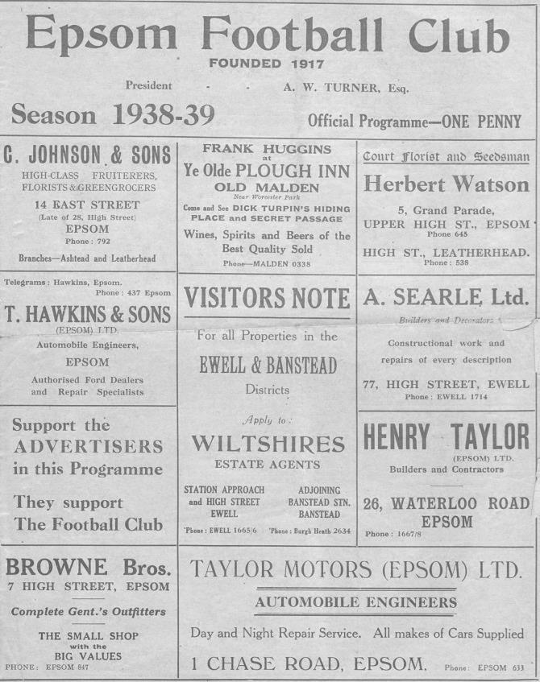
78 years ago today spectators witnessed one of the strangest matches in our entire history as Kent based Bostall Heath visited West Street for a London League match. We would be runners up that season and started in a confident manner, taking the lead after quarter of an hour and continuing to race down the hill at them. We led 5-0 at half time, thanks mostly to a Fred Stenning hat trick.

However, the visitors replied with two quick goals in the second half and amazingly fought back to draw 5-5 with all ten goals in the bottom net! This record stood until August of this year when we saw eleven goals in the same net from our 9-2 win at Bedfont & Feltham!

50 years ago today we had just been suspended by the Surrey F.A. due to our disciplinary record! Fortunately our Chairman George Tarran led an appeal and the suspension was lifted. We celebrated this the next day at Wingate’s long lost Hall Lane ground with a bizarre 7-5 League win that didn’t contain a single foul in it, said the reports, which described the match as like nuns against vicars, so well behaved were the teams! The ground itself now sits under the M1 near Hendon!

20 years ago this week we had a home match with Aveley at Merland Rise. Everybody who knows the ground will know that it can be cold and windy most of the time. This particular day was generally regarded as the windiest day we had up there, although with the wind at our backs and in true Epsom form, we conceded early! However we fought back to lead 3-1 and could not understand why their keeper seemed quite content to waste time. The answer became clear in the second half as they rattled in four goals with the wind advantage to defeat us 5-3!

11 years ago today we took a very young team to Ware who were in fine form, while we weren’t! They smashed us 7-0 at Wodson Park and after the match long-serving Nigel Bennett surprisingly chose to retire, despite being only half a season away from breaking Graham Morris’ appearance record! To my knowledge he has never returned to the club. Maybe fortunately, we have not been back to Ware since then and it remains the last time we conceded seven goals on our travels!

Centre page for results

Centre page for results

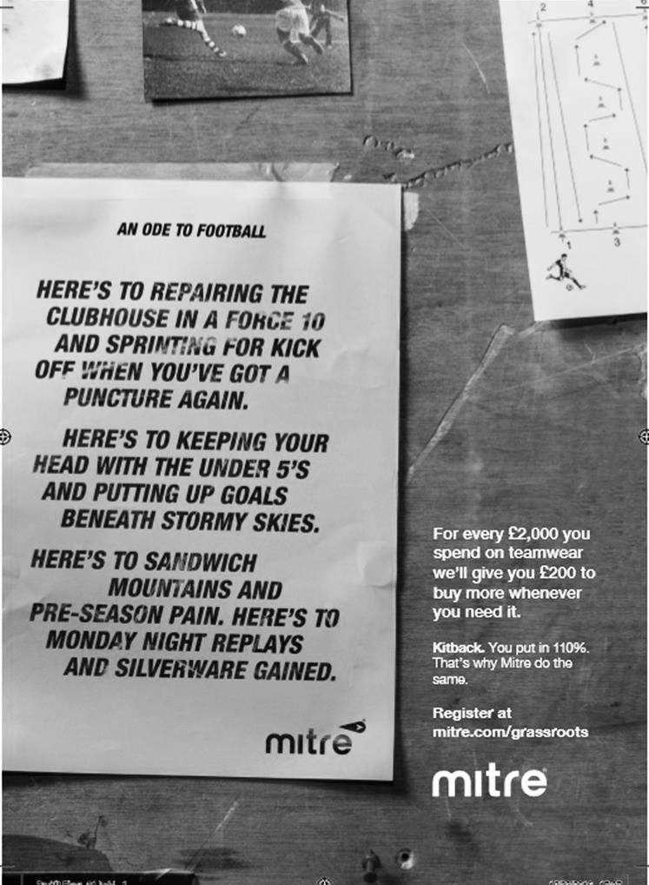

Surrey Senior Cup
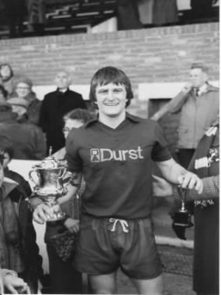
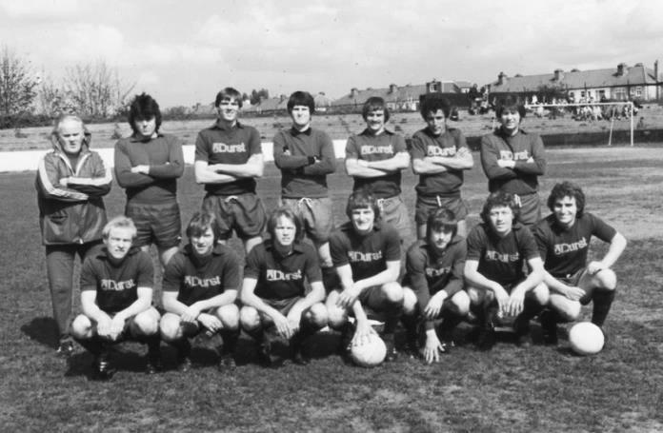
Second Round
Met Police | 0-0 | Kingstonian
Match played at Met Police F.C. – Kingstonian won 7-6 on penalties
Ashford Town (Mx) | 0-1 | Knaphill
Woking | 4-0 | Walton Casuals
Whyteleafe | 5-1 | Colliers Wood United
Guildford City | 3-3 | Horley Town
Guildford City won 3-2 on penalties
Egham Town | 3-0 | Corinthian Casuals
Godalming Town | 0-1 | Merstham
Molesey | 0-1 | Leatherhead
Raynes Park Vale | 1-1 | Sutton United
Raynes Park Vale won 4-3 on penalties
Sutton Common Rovers | 5-1 | Camberley Town
Dorking Wanderers | 2-1 | South Park
Badshot Lea | 1-0 | Farnham Town
Walton & Hersham | 3-0 | Croydon
Carshalton Athletic | 0-2 | Tooting & Mitcham United
Chertsey Town | 2-1 | Abbey Rangers
Epsom & Ewell | 3-0 | Chipstead
Third Round
Whyteleafe | V | Egham Town
Badshot Lea | V | Raynes Park Vale
Epsom & Ewell | V | Guildford City
Dorking Wanderers | V | Sutton Common Rovers
Kingstonian | V | Chertsey Town
Woking | V | Leatherhead
Merstham | V | Walton & Hersham
Tooting & Mitcham United | V | Knaphill

EL Records Premier Challenge Cup
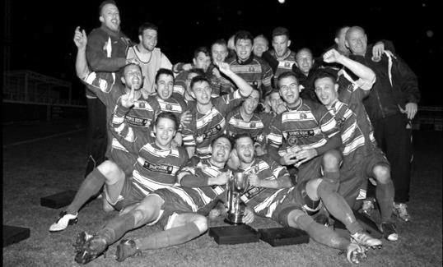
Second Round
Hanworth Villa | 2-4+ | Epsom and Ewell
AFC Hayes | 3-4 | Balham
Epsom Athletic | 1-5 | Windsor
Sutton Common Rovers | 2-1 | Bedfont Sports
Raynes Park Vale | 2-0 | Colliers Wood United
Frimley Green | 1-2 | Banstead Athletic
Westfield | 8-4+ | Redhill
Staines Lammas | 0-1 | Farnham Town
Worcester Park | 8-1 | Cove
Badshot Lea | 0-5 | Guildford City
Chertsey Town | 1-2 | Camberley Town
Cobham | 1-3 | Chessington & Hook United
Hartley Wintney | 4-0 | AC London
Horley Town | 2-2+ 5-4p | Sheerwater
Walton & Hersham | 5-1 | Eversley & California
Ash United | 2-0 | Farleigh Rovers
Third Round
Banstead Athletic | 4-4+ 3-4p | Westfield
Sutton Common Rovers | 19/12 | Walton & Hersham
Farnham Town | 0-4 | Camberley Town
Ash United | 0-2 | Windsor
Raynes Park Vale | 2-1 | Hartley Wintney
Guildford City | 2-1 | Balham
Horley Town | 2-0 | Chessington & Hook United
Worcester Park | 3-6 | Epsom & Ewell
Quarter Finals
Windsor | 24/1 | Horley Town
Guildford City | 25/1 | Raynes Park Vale
Westfield | 17/1 | Camberley Town
Sutton Common Rovers /  Walton & Hersham | V | Epsom & Ewell

Every Opponent A-Z
Over the years we have played many, many different opponents. Exactly how many is a difficult question, as it all depends on your definition. Are Camberley & Yorktown different to Camberley Town, or are Epsom Town different to Epsom F.C. or Epsom & Ewell F.C.?

In my analysis I have classed both of the above examples as the same team, and will work through them all from A to Z. Some we have played many times, whilst others we have met just once or twice. Enjoy!

Thames Polytechnic: Played 2 - W2 D0 L0 - F4 A0 - PPG - 3.00 - Perfect

We have played Thames Poly on two occasions in the London Senior Cup. We defeated them on 10th September 1977 by a single Tommy Tuite goal and then ten years later we were drawn away to them in the same competition but the match was switched to West Street where Brian Perkins scored a second half hat trick in our 3-0 win. Although we never went there, they played their home matches at Kidbrooke Lane, Well Hall in Eltham which is a ground we played at frequently when used by Woolwich Polytechnic, first making the journey as an Intermediate status side way back in 1923 and then continuing after World War Two in the London League from 1946-48. They were playing in the Kent County League as recently as 2002/03 but from there the records disappear.

Tring Town: Played 27 - W9 D8 L10 - F47 A37 - PPG - 1.30 - Average

Now this one came as a surprise to me. I can recall many good results against Tring Town, yet we have a losing record. Our goal difference is much better though and I will get to that later.

We first met Tring as an Athenian League opponent in the 1975/76 season. We had spent a couple of seasons in the Surrey Senior League, while they had spent much of their existence in the Spartan League with limited success, except for a League title in 1967/68, so both clubs were new to the League for this season. Despite our promotion against their sixth place finish that season, they defeated us home and away, 1-0 at Cow Lane and 2-0 at West Street.

The following season the clubs did not meet, but with the formation of the Isthmian League in 1977, almost all of the Athenian League Division One were invited if their ground grading was good enough. Additionally, Farnborough Town and Tring were also invited so we all became Isthmians at the same time. The results didn’t really improve though, despite our club being the first Champions, as we lost 3-0 at home before scraping a 2-2 draw over there on the Easter Monday.

The remainder of our meetings all took place in a ten year span, during which we were both founder members of the Isthmian Division Three, having finished in the lower halves of the two regional Division Twos in 1990/91.

On Wednesday 19th February 1992 we made our first visit to Cow Lane for nearly 14 years. It was my first visit too and we won 3-1. The Pendley Sports Centre was a strange venue really. It had an old creaking stand that you could only enter from the back up some steep steps and it must have felt extremely precarious sitting in there on a windy day! Additionally, matches were occasionally interrupted by a whistle or rugby ball coming from the nearby Tring Rugby Club that were positioned adjacent to the ground!

We completed a league double for the first time with a 2-0 win at West Street in April 1992 and the following season we won over there again, yet slipped up 1-0 at home on Tring’s last ever visit to West Street on 6th March 1993. As a team more frequently positioned in the top half of the division we probably used to look at Tring as a three point banker, based purely on their regular league position. However, our record against them gave no reason to suggest that this should be

the case and this was illustrated in 1993/94 when we were held to draws in both matches while the following season we drew one and lost one.

We drew once again over there on 28th October 1995 to make it five matches without a win but the return match on Thursday 11th April 1996 would go down in Epsom history as we crushed them by eleven goals to one at Merland Rise to record our second biggest ever league win and it was our third highest ever score, only surpassed by the 13 against Reigate Priory in the 1935/36 Amateur Cup and 12 against Acton in the post war London League 1945/46 season.

It was an incredible match. We led inside 30 seconds through Kevin Webb and the goals just kept coming. Andy Boxall scored one goal by twisting the keeper so badly that he had to go to hospital for treatment! With the score at 6-1 at half time, they then had a player sent off and the score quickly increased to eight with three late goals coming in the final five minutes to register an incredible scoreline with Boxall equalling the club scoring record with six goals.

Incredibly in our next match against them in November we lost 2-1 over there despite them fielding an outfield player in goal! These were tough times for the club and a clubhouse fire didn’t help their plight whatsoever.

In February 1997 we had another strange match, at Merland Rise leading 2-0 at half time and totally in charge, yet somehow we conceded three times to trail, before fighting back to win 4-3.

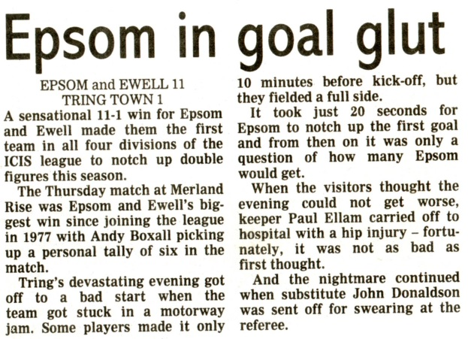
In 1997/98 we lost 2-1 at home and were again only able to secure a 1-1 draw at Cow Lane, but the 1998/99 heralded a slight improvement with home wins in the Associate Members Trophy and in the League by 2-0 and 3-0 respectively, although we still lost there.

The first meeting of the 1999/00 season was another strange one as we trailed 3-0 at the break yet pulled It back to 3-3 very quickly, only to have to settle for the draw, despite immense pressure. At least this time we managed an away win with a Steve Latuske goal being sufficient to claim the points on Wednesday 26th April 2000. In 2000/01 we secured a win and a draw but in our final pair of meetings in 2001/02 we were again beaten home and away. It is a quite incredible statistic that we have been promoted on five occasions since the war and in three of those seasons Tring were in there with us and despite finishing lower, recorded five wins and a draw against us from those six matches!

We went on to have a very successful 2002/03 in the Isthmian Division One South but for Tring Town things were very much darker as they finished tenth and then failed to exist! Officially they were then absorbed in 2003 by local neighbours Tring Athletic who could not get lights up at their own ground, so moved to Cow Lane in some sort of partnership, but if there had been any element of Tring Town remaining, they would surely have been allowed to continue in the Isthmian League, which they weren’t.

So the story ended then and there for Town, although the ground continues to be used to this day by Tring Athletic, playing at Step Five in the South Midlands League. Maybe one day we will go there again, where the rickety stand survives to this day!

Player Sponsorship
Here is the current list for the 2016/17 season showing all of our players and Management that are available for sponsorship.

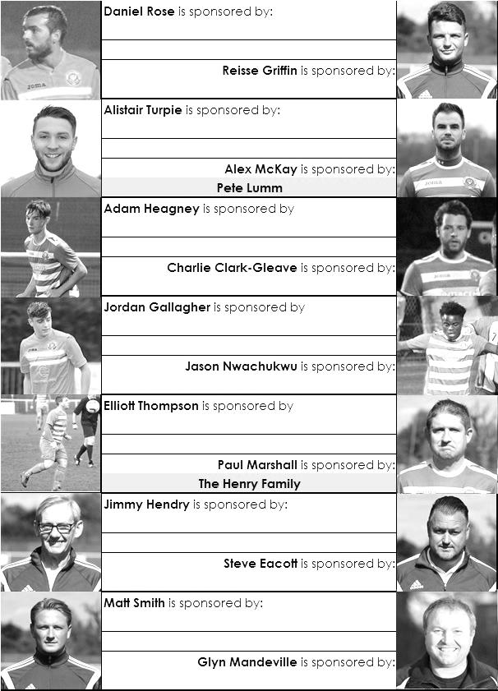

Sponsorship costs just £40 and it is easy to do. Just select a player who has not been previously sponsored and let a Committee Member know that you would like to sponsor them. Beware though. Until we have received the money it is possible for someone to jump in front of you, so don’t delay, sponsor today!
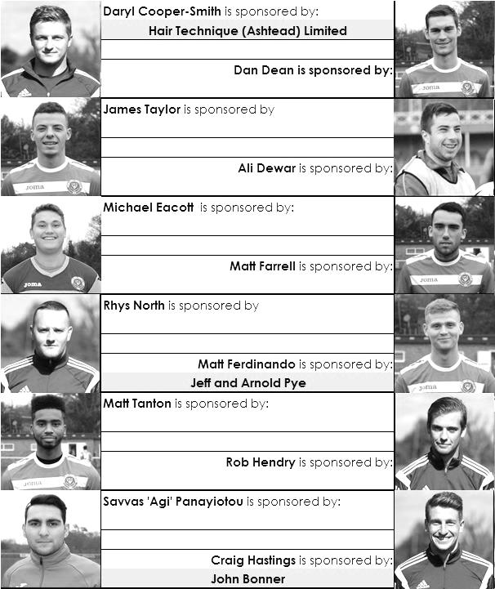

Match and Ball Sponsorships – 2016/17
Opponent | Date | Match Sponsor | Ball Sponsor
Gravesham Borough | 07/08/16 | Club President - Stella Lamont
Gravesham Borough | 07/08/16 | Relocation Committee Member - Mike Lovett
CB Hounslow United | 16/08/16 | EEFC Management Committee
Abbey Rangers | 23/08/16 | Steve & Geoff Dyke
Horley Town (11.30am) | 29/08/16 | In Memory of Chris Henry
Abbey Rangers (LC) | 06/09/16 | Paul Merritt
Camberley Town | 10/09/16 | Building Shop Ltd
Knaphill | 24/09/16 | EEFC Holding Company Director – Pete Lumm
Bridon Ropes (FAV) | 22/10/16 | George and Joseph Saunders
Sutton Common Rovers | 08/11/15 | Alex McKay Senior
Abbey Rangers (FAV) | 13/11/16 | EEFC Holding Company Director – Dave Ellins
Windsor | 15/11/16 | In Memory of Wally Dyke
Bedfont Sports | 19/11/16 | John Bonner
AFC Hayes | 26/11/16 | Jack Jarman
Chipstead (SSC / DWT) | 06/12/16 | Trevor Stotten
Hanworth Villa | 13/12/16 | Roger and Carol Farrell
Chertsey Town | 17/12/16
Raynes Park Vale (11.30am) | 27/12/16
Spelthorne Sports | 07/01/17
Guildford City | 17/01/17
Bedfont & Feltham | 21/01/17 | Programme Editor - Richard Lambert
Badshot Lea | 04/02/17
Westfield | 18/02/17
Walton & Hersham | 04/03/17
Hartley Wintney | 18/03/17
Farnham Town | 25/03/17
Colliers Wood United (1pm) | 14/04/17 | Good Friday match – make a note!
North Greenford United | 22/04/17 | Club President - Stella Lamont
Guildford / Horley (SSC) | tba
For League, League Cup and Surrey Senior Cup Matches:
Match sponsorship - £40.00 Match ball sponsorship - £25.00. Combined £55.00.
For F.A. Cup and F.A. Vase matches:
Match sponsorship - £50.00 Match ball sponsorship - £30.00. Combined £65.00.

Sponsorship includes: (x2 for match, x3 for match and ball)

Admission, programmes, hospitality and advertising and mascot for the day (if required).
If you are interested, just speak to a Committee Member, or drop me an email at: richard.c.lambert@gmail.com

We also thank our Kit Sponsors INTERCEM

Salts Super Six Predictor
The Salts Super Six Predictor is live again for today’s match and the tickets are on sale at today’s game to the left of the gate.

The jackpot was won on Wednesday with two people receiving £280 each. Congratulations go to Rita Christian and Matt Parker who will be receiving their money shortly. As a result, the jackpot goes back to £50 again for today’s matches.

The competition is easy to play! To win, you simply need to predict the results of six matches correctly from the three options, fill in the form and make sure it is back with our seller before the deadline on the ticket. The latest fixtures are shown below.

If you are a club regular, you just need to place your name on the sheet, although if you aren’t, then we’ll need a contact number from you too. We will announce any winners on the website within three working days, so don’t worry, we won’t miss you!

Please note that if there is more than one winner, the prize pot would be shared between the winners. All you need to do now is have a go, as many times as you like!

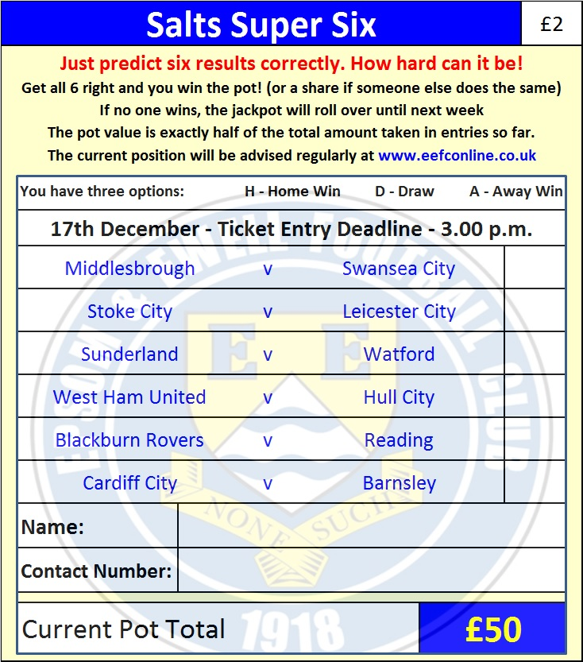

Good luck!

Combined Counties League – Premier Division
Saturday, 17th December 2016 - Kick-off 3.00 p.m.

Epsom and Ewell  (Royal Blue & White hoops) | V |  | Chertsey Town  (All Red)
Squad | NUMBERS |  | Squad
Michael Eacott |  |  | Chico Ramos
Adam Heagney |  |  | Steve Newman
Matt Tanton |  |  | Ben Geraughty
James Taylor |  |  | Tommy Batten
Craig Hastings |  |  | Meddie Nsubuga
© Dan Dean |  |  | Joe Jones
Jordan Gallagher |  |  | Jamie Ross
Matt Farrell |  |  | Jack Wadmore
Daryl Cooper-Smith |  |  | John Pomroy
Savvas ‘Agi’ Panayiotou |  |  | Connor Cullen
Matt Ferdinando |  |  | Andy Crossley
Jason Nwachukwu |  |  | Joel Thompson
Reisse Griffin |  |  | Lewis Wade
Rob Hendry |  |  | Shelton Gooden
Alex McKay |  |  | Connor Young
Daniel Rose |  |  | Will Montague
Alistair Turpie
Charlie Clark-Gleave
Matt Smith
Glyn Mandeville | MANAGER |  | Carl Taylor
Matt Smith | ASSISTANT
Steve Eacott /  Alex McKay /  Jimmy Hendry | COACHES / PHYSIO |  | Dan Dullaway /  Megan Jones
REFEREE: T.Yesilyurt
ASSISTANTS: K.Corrick, I.Hempel

OUR NEXT VISITORS TO HIGH ROAD
Raynes Park Vale
Combined Counties League – Premier Division
Tuesday 27th December 2016 – 11.30 a.m.

